

**Payroll System**

**POSEgg005**

HUEVO – FEBRUARY 2017

|  |  |  |
| --- | --- | --- |
| **SCRUM TEAM** | **SPRINT NAME AND DURATION** | **CHANGES** |
| Huevo | POSEgg002  18/Feb/17  to  04/March/17 | * **Employee Master list Page** |

**POSEgg005**

This story includes the creation of Employee Master list page. The Employee Master list Page can view Master list of the employees. The team are creating master list page were you can see the add employee button the admin must able to access the add employee, deactivate employee and view information. The user must go to login page to validate the username and password to provide security of the user.

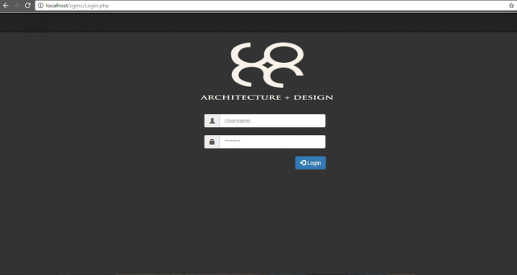

1. Adding Login Page Procedures

Step1: Click Start Button

Step2: Open Xampp and Start MySql , Apache

Step3: Open any available browser

Step4: Browse “localhost/cgmc”

Step5:Click “loginpage.php”

1. Process of Authentication Procedures

Step1: Insert Valid Credentials (Username, Password) then click the login button

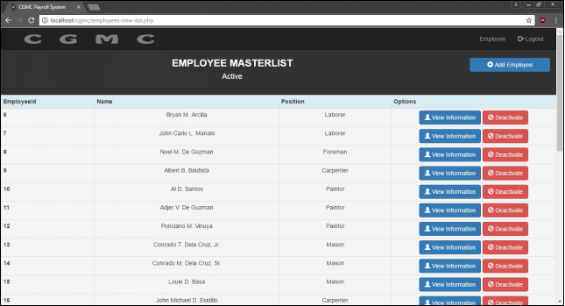

1. Data validation for all fields, the basic information of the employee will save. If the user input invalid data or skip one or more field it might not be save. Procedures are:

Step1: Click the add employee button

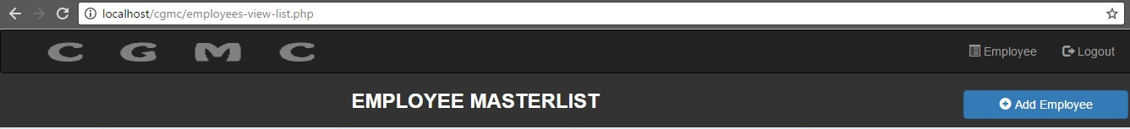

Step2: User must fill up all the data that the system demand and it is also required to input valid data according to the field needed

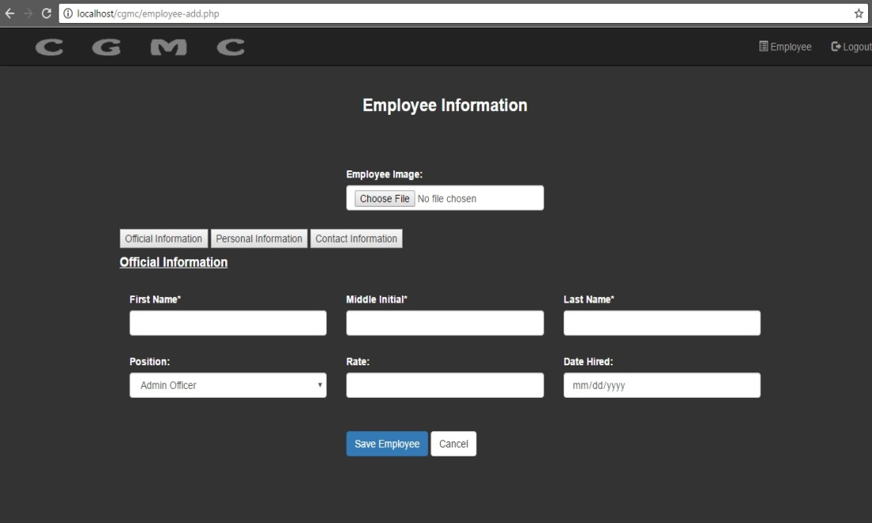

Step3: When the user input invalid data or skip required data. Error message will appear.

1. Adding option box for gender field, the option box that the user chose will add in the basic information of the employee. Procedures are:

Click the add employee button the user will fill up the data needed. The user may choose only one data.

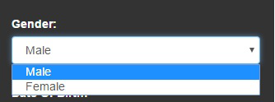

1. Date picker for date

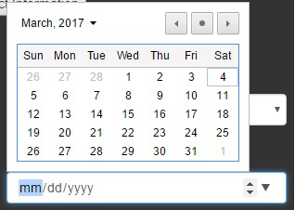

1. Deactivate to enable

